**Day 5**

**What to do?**

Learn more about Multi-Layer perceptron.

**Multi – Layer Perceptron:**

If a single layer single neuron network is called a single layer perceptron, then when a network contains more than one layer, then it is multi-layer perceptron! I have also learned that there is a minute difference between NN and MLP. And that is MLP is a type of model whose output is binary, whereas NN has now advanced a lot to do multi-classification and regression using various activation functions.

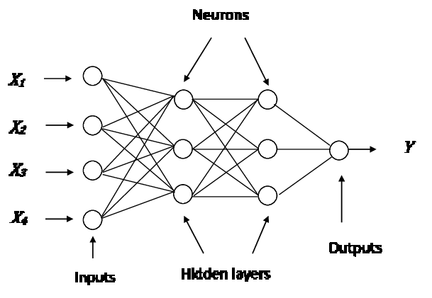

To explain the concept, let us take the image above. Basically, it is a 3 – layer MLP (we do not consider the input layer). The 4 input features are fed to first hidden layer L1, which contains 3 neurons. Here, each input is connected to every neuron (4 X 3 connections: weights and biases = 3 weights and bias for every input). Now the three perceptrons that received the output from input features, is again sent as input to the 2nd hidden layer L2, which also contains 3 neurons. This time the total number of connections are 9 (3 X 3). The perceptrons do their respective calculations using activation functions and send the output to the next layer (output layer) perceptron(s).

For each signal, perceptron uses different weights to produce different output!